**DEEPALAYA SCHOOL**

A-14, KALKAJI EXTENSION, NEW DELHI -19

Admission Schedule for Entry Level Classes 2025-26

COMMENCEMENT OF ADMISSION PROCESS AND AVAILABILITY OF FORMS **28-11-2024 (Thursday)**

LAST DATE OF SUBMISSION OF APPLICATION FORMS IN SCHOOL **20-12-2024 (Friday)**

THE DATE FOR DISPLAYING THE FIRST LIST OF SELECTED CHILDREN **17-01-2025 (Friday)**

**Upper age limit for admission in entry level classes**

**Born between 01/04/2021 - 31/03/2022**

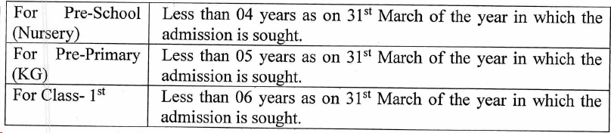

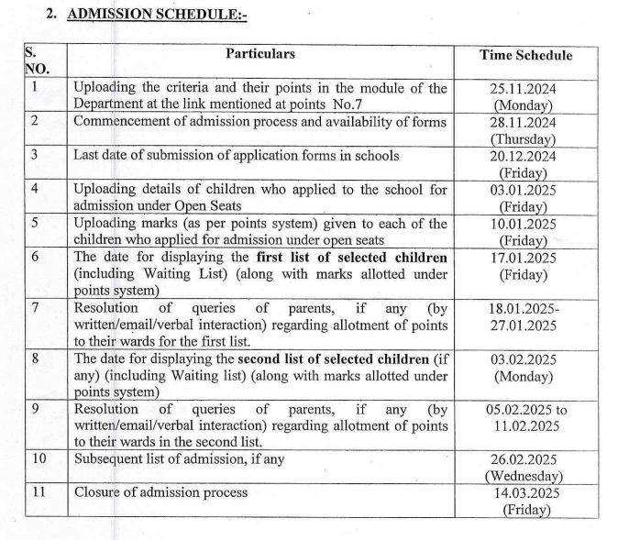

**ADMISSION CRITERIA FOR ENTRY LEVEL CLASS**

**2025-26**

|  |  |  |
| --- | --- | --- |
| S.NO | CRITERIA | MARKS |
| 1 | Distance |  |
| a | 0 km to < 2 km | 25 |
| b | 2 km to < 3 km | 20 |
| c | 3 km to < 5 km | 15 |
| d | 5 km to 10 km | 10 |
| 2 | Girl Child | 20 |
| 3 | Sibling | 10 |
| 4 | Minority Christian | 30 |
| 5 | Staff | 10 |
| 6 | Alumni | 5 |